**MGS 9920 Prob & Stat Theory I**

**Homework 11: Means and Proportion of Two Populations**

**6.**[Page 401]

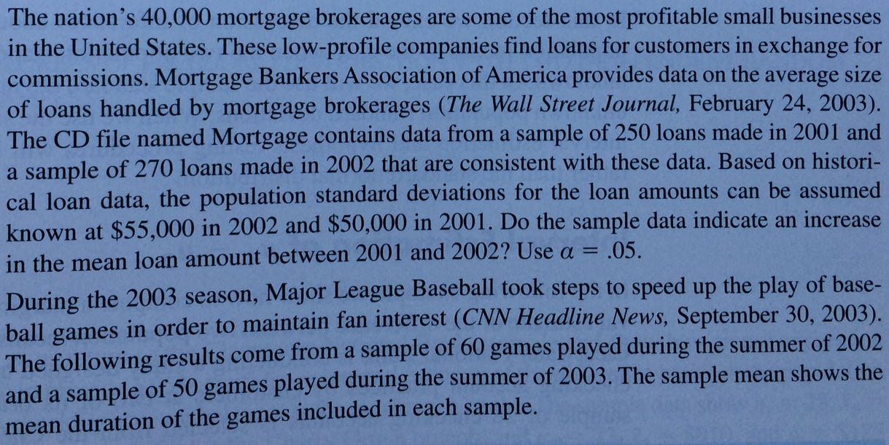

**14.**[Page 408]

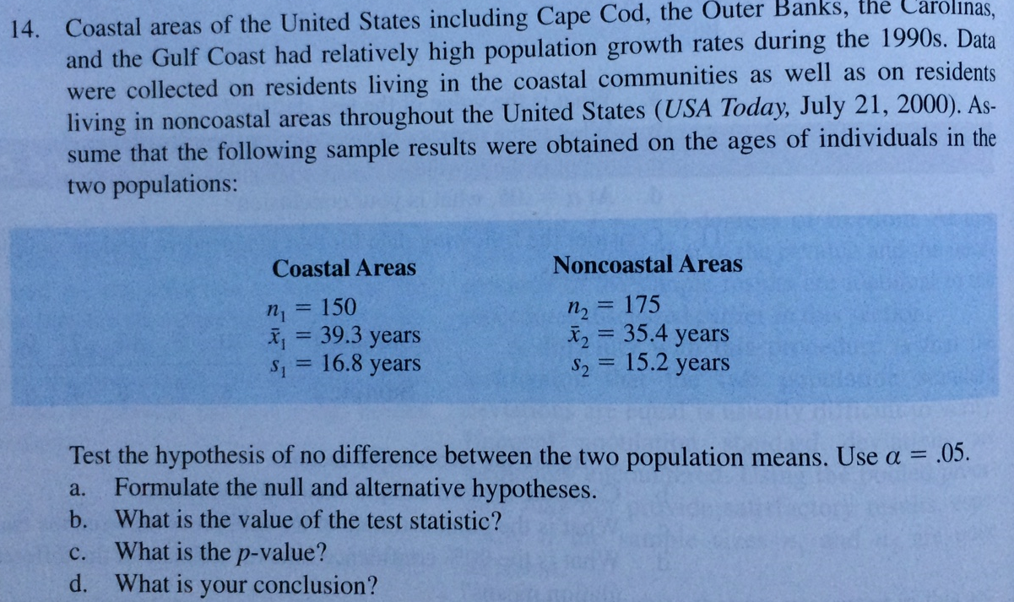

**25.**[Page 415]

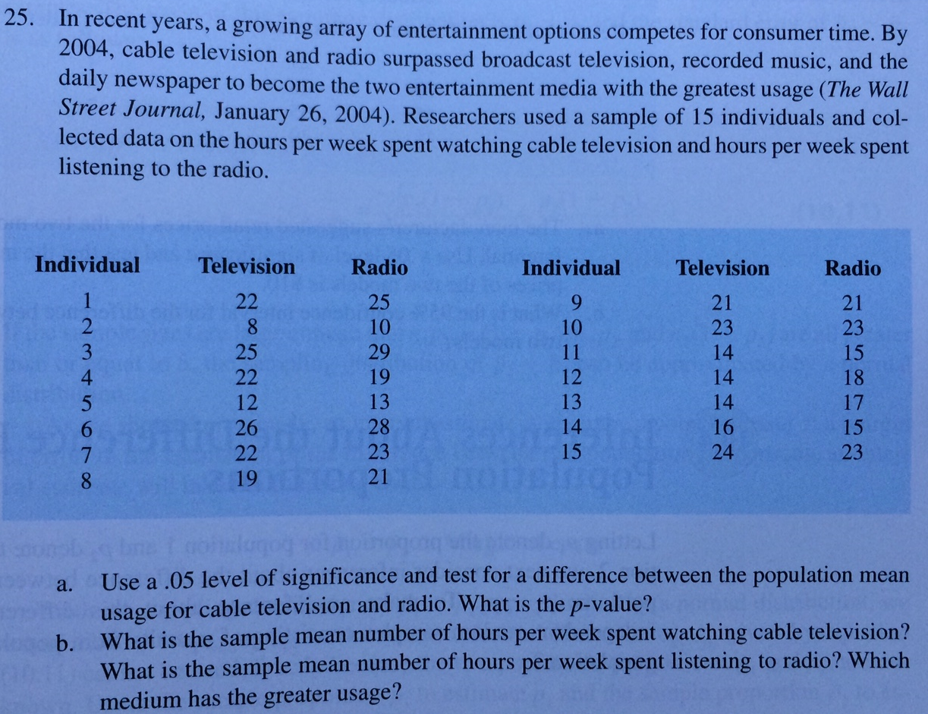

**32.**[Page 421]

